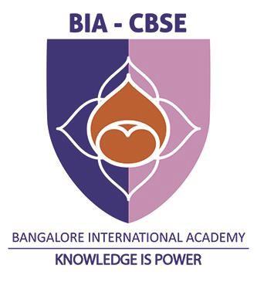

NEHRU SMARAKA VIDYALAYA   
 BANGALORE

Investigatory Project in Computer Science   
 Topic:

Vehicle Management System

Submitted to

Mrs Kopal Aggarwal   
 Submitted by

Tanish H Talapaneni   
 Grade 12



NEHRU SMARAKA VIDYALAYA

Certificate

This is to certify that _________________ bonafide   
student of class 12 has successfully completed the project   
titled Vehicle Management System in the laboratory of   
Computer Science prescribed by the Central Board of   
Secondary Education for the AISSCE for the year 2019-20

Teacher in - charge HOD Principal

External Examiner   
Date:

Acknowledgement

I wish to express my gratitude to my Computer Science  
teacher who has been instrumental in helping me   
complete this project.

I also wish to express my sincere thanks to our beloved   
Principal Dr Anil Kumar T The Management of BIGI   
for having changed our focus from exam-based learning   
to knowledge-learning which I now understand will go   
a long way in molding my future ahead for better   
prospects.

I wish to thank my parents, friends and all those who   
have directly or indirectly contributed towards   
completion this project effectively.